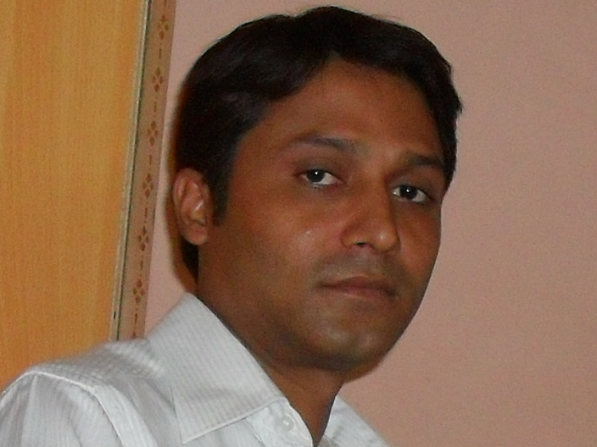

**Ram Ram Kumar Pandey**